In-Class Activity: Designing & Evaluating Training
Course Objectives: Knowledge; Application

When you graduated, you will all be trained as Psychology majors. Did we do a good job of training you? How could you evaluate the Psychology program? For this activity, you will create an actual evaluation tool that could be given to Ramapo psychology graduates. Specifically, you need to include:
- What are we training?
  - Write two paragraphs explaining what is the goal of the Psychology “training” – i.e., what KSAOs should you have learned after finishing a Psychology degree? Whatever you write here will be what I judge your actual evaluation on (i.e., I will grade whether or not your evaluation actually measures what you have here).
- Evaluation tool
  - Reactions Criteria: you should include a minimum of five questions.
    - This should be formatted realistically!
  - Learning Criteria: you should include a minimum of five questions.
    - This should be formatted realistically!
  - Behavior Criteria: How might the university measure behavior impact of psychology training? Write one paragraph explaining what and when you’d measure. Who do we need to ask to measure impact? When?
  - Results Criteria: Write one paragraph explaining what and when you’d measure. Who do we need to ask to measure impact? When?
  - BONUS: How might we create and calculate the ROI of a Psychology Degree? Write some ideas you’d have to create a calculation of ROI.
- An overall explanation write-up
  - Write two paragraphs reflecting on your evaluation. What do you think of your evaluation tool? Does it do a good job of evaluating the training Psychology majors received? Which criteria do you think do the best job of evaluating? Which do you think would be most helpful for faculty members to use to improve the program?
Grading:
- What are we training?
  - Is your discussion of what KSAOs the Psychology program aims to train in-depth and well thought out?
- Evaluation tool
  - Are the questions you included good examples of Reactions and Learning criteria? Is your explanation of Behavior and Results criteria in-depth?
  - Are the Reactions and Learning questions formatted realistically – are they ready to be given to college graduates?

- Overall Write-Up:
  - Is your reflection and discussion of your evaluation program in-depth and well thought out?

You must upload this to the link on Canvas by the end of class today.
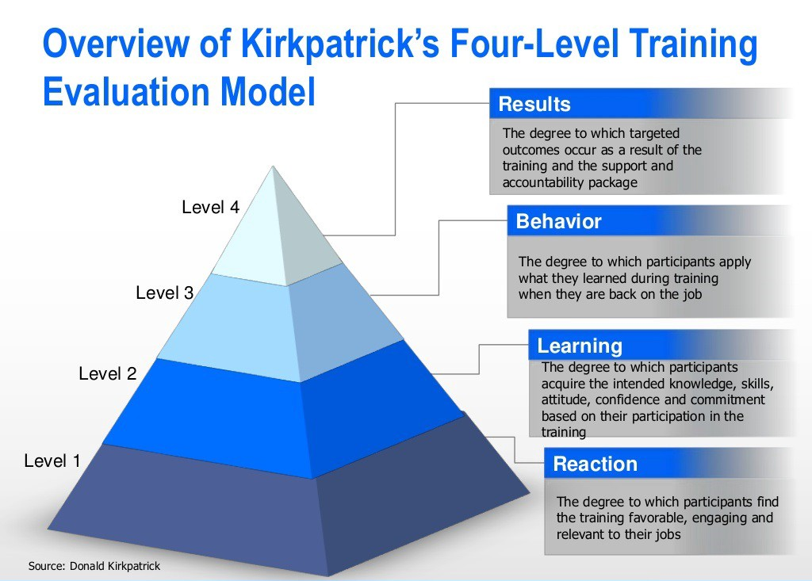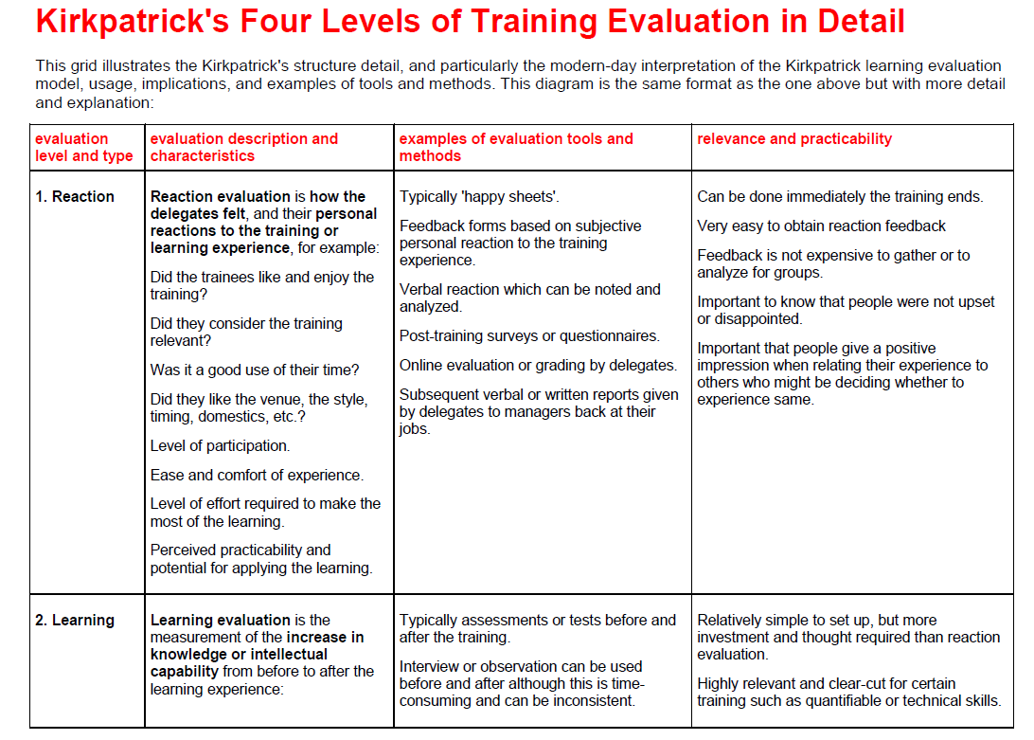
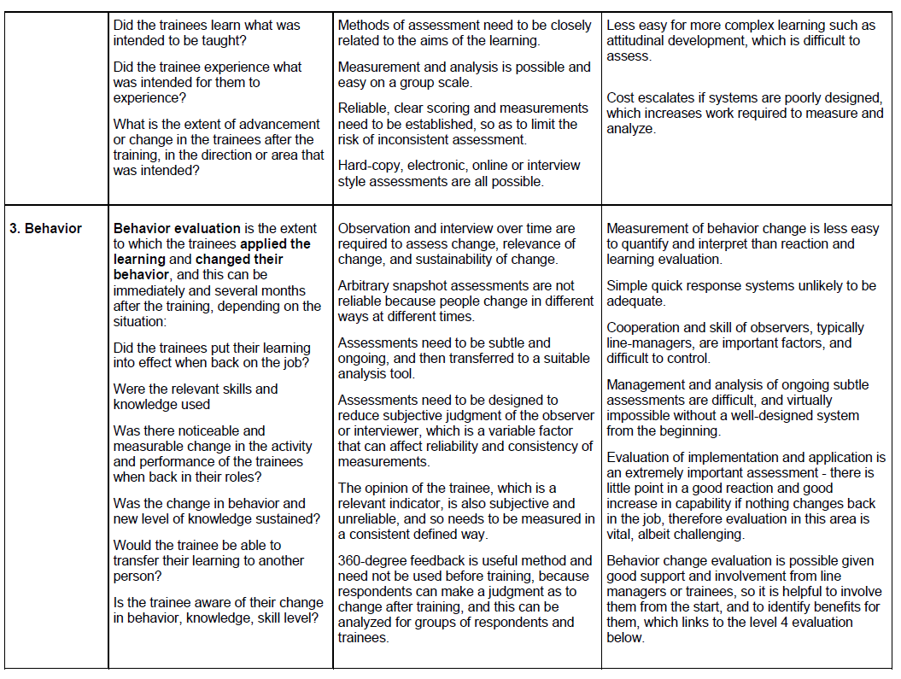
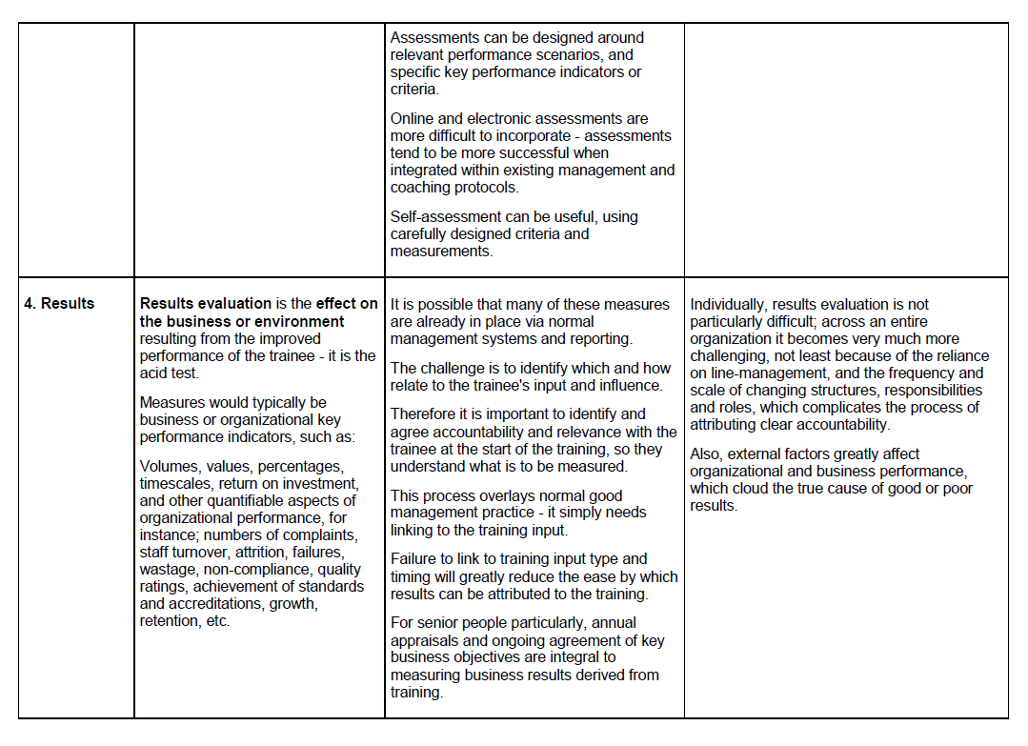
Helpful Ideas Helpful Ideas 2
